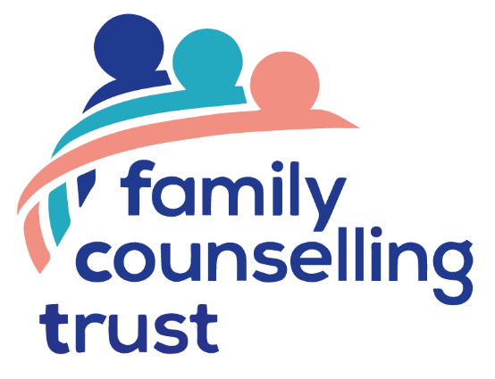

Family Counselling Trust

Privacy Notice:
Children, Young People and Families

Background
The Family Counselling Trust (‘FCT’) is committed to ensuring your personal information is protected. This privacy notice describes how the FCT, the data controller, collects, uses and protects information relating to children, young people and families who have been referred to us.

How we collect your information
We receive personal information through referral forms received directly from family members, GPs, schools, health care professionals, or other voluntary or professional bodies. We may also collect information during the course of your involvement with us.

The type of information we hold
This information may include name, address, date of birth, contact telephone numbers, email address, income band, and personal sensitive information such as medical history.

How we use your information
We use your information to determine how the FCT can support the request for counselling services. This information is processed for the lawful reason of fulfilling the contract between us in relation to our services.

Who we will share your information with
The FCT will share personal information with the relevant Family Liaison Officer, relevant practitioner, and limited members of the Trust as necessary.

We will not share personal information with any other organisation unless there is a legal or regulatory requirement to do so.

Storing your information
Your personal information will be stored on personal systems owned by our Family Liaison Officers and limited members of the FCT.

Retention
We retain information while we are providing our services and we retain this information for up to 7 years after we have stopped providing our services when it will be destroyed.

How you can access your information
You have the right to request access to the information we hold about you. To make a request for your personal information, please contact the relevant county lead listed further below.

You also have the right to:
- object to processing of personal data that is likely to cause, or is causing, damage or distress;
- have inaccurate personal data rectified;
- request your information to be deleted or destroyed and if we can we will but sometimes we must maintain some records for legal reasons.

Your Rights
If you are not happy with how we are using your information or how we have responded to your request, you have the right to complain to the Information Commissioner’s Office at www.ico.org.co.uk.

How we will tell you about future changes to this privacy notice
Any changes we make to our privacy notice will be put on our website. Please check for updates from time to time so you are always fully aware of what information is collected and how it is used.

How to contact us
If you have any questions or concerns about our use of your personal information please email for:
Dorset: Robert Montagu email: robmontagu@aol.com
Hampshire: Brian Welch email: safeguardingtrustee@familycounsellingtrust.org
Somerset: Susannah Walker email: chair-somerset@familycounsellingtrust.org
Wiltshire: Alison Sankey email: chair-wiltshire@familycounsellingtrust.org

Privacy Notice:

Donors and Fundraisers

Background
Family Counselling Trust (‘FCT’) is committed to ensuring your personal information is protected. This privacy notice describes how the FCT, the data controller, collects, uses and protects your information.

How we collect your information
The information we hold about you comes from the way you engage with us, such as if you donate money, or become involved in fundraising for our organisation. We may collect information about you online through our website, donation forms, email, post, over the phone or from discussions with you.

The type of information we hold
The information we hold may include name, address, contact telephone numbers, email addresses, bank details and donation history.

How we use your information
We use your information in the following ways:

The legitimate charitable business interest to provide you with the information you requested and information on our activities.

To process your donations.

We are legally required to hold some personal information to fulfil our statutory obligations, for example the collection of Gift Aid or certain financial transactions.

Who we will share your information with
We will not sell or swap your information with any agency or other charity. We may however share your information with our professional advisers and with HMRC for Gift Aid purposes.

Storing your information
Your personal information will be stored on FCT’s accounting systems and/or on personal systems owned by our Family Liaison Officer and limited members of the FCT.

Retention
We will retain your personal information in accordance with legal and regulatory requirements. We will only retain your information while we are actively engaged with you. Where we have had no interaction with you for a period of 6 years we will delete your data.

How you can access your information
You have the right to request access to the information we hold about you. To make a request for your personal information, please write to us using the contact details below.

You also have the right to:
- object to processing of personal data that is likely to cause, or is causing, damage or distress;
- have inaccurate personal data rectified;
- request your information to be deleted or destroyed and if we can we will but sometimes we must maintain some records for legal reasons.

Your Rights
If you are not happy how we are using your information or how we have responded to your request, you have the right to complain to the Information Commissioner’s Office at www.ico.org.co.uk.

How will we tell you about future changes to this privacy notice
Any changes we make to our privacy notice will be put on our website. Please check for updates from time to time so you are always fully aware of what information is collected and how it is used.

How to contact us
If you have any questions or concerns about our use of your personal information please write to the CEO at FCT, 5 Cedar Road, Charlton Down, Dorchester, Dorset DT2 9UL or email us at info@familycounsellingtrust.org.

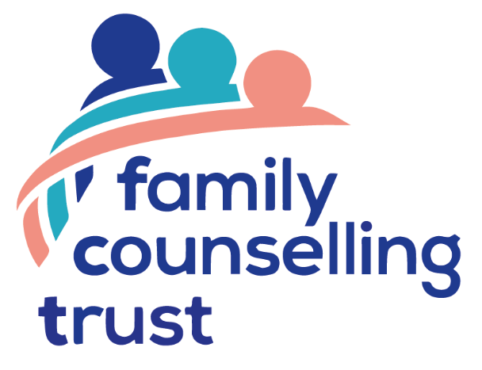

Family Counselling Trust

Privacy Notice:

Volunteers including Trustees, Practitioners and Family Liaison Officers

Background
Family Counselling Trust (‘FCT’) is committed to ensuring your personal information is protected. This privacy notice describes how the FCT, the data controller, collects, uses and protects information relating to our practitioners, family liaison officers and volunteers.

How we collect your information
The information we collect is from your application form, references from third parties, DBS checks, and information collected throughout your association with us.

The type of information we hold
This information may include name, address, contact telephone numbers, email address, bank details, professional qualifications, employment history, membership of professional bodies, professional indemnity insurance and DBS status.

How we use your information

We process personal data relating to those we engage to work with the FCT for the lawful purpose of fulfilling the contract and to enable individuals to be paid.

In addition, we process information about volunteers, practitioners and family liaison officers for the following legitimate charitable business interest:

- To manage and communicate with volunteers, practitioners and family liaison officers.
- To support the work of the charity.
- To enable the charity to make appropriate decisions about the provision of therapy services to children and families.

Who we will share your information with?
The FCT will share personal information with our Family Liaison Officers our professional advisers and limited members of the trust as necessary.

We will not share personal information with any other organisation unless there is a legal or regulatory requirement to do so.

Storing your information
Your personal information will be stored on FCT’s accounting systems and/or on personal systems owned by our Family Liaison Officers and limited members of the FCT.

Retention
We will retain your personal information in accordance with legal and regulatory requirements which can be found in the retention schedule of our Privacy Policy available via on our website.

How you can access your information
You have the right to request access to the information we hold about you. To make a request for your personal information, please contact the relevant county lead listed further below.

You also have the right to:
- object to processing of personal data that is likely to cause, or is causing, damage or distress;
- have inaccurate personal data rectified;
- request your information to be deleted or destroyed and if we can we will but sometimes we must maintain some records for legal reasons.

Your Rights
If you are not happy how we are using your information or how we have responded to your request, you have the right to complain to the Information Commissioner’s Office at www.ico.org.co.uk.

How we will tell you about future changes to this privacy notice
Any changes we make to our privacy notice will be communicated to all staff and volunteers by via our website and by email.

A copy of the privacy notice is available to all volunteers and practitioners via our website.

How to contact us
If you have any questions or concerns about our use of your personal information please email:

Dorset: Robert Montagu email: robmontagu@aol.com
Hampshire: Brian Welch email: safeguardingtrustee@familycounsellingtrust.org
Somerset: Susannah Walker email: chair-somerset@familycounsellingtrust.org
Wiltshire: Alison Sankey email: chair-wiltshire@familycounsellingtrust.org

